Design Ideation

Team 207

EGR-314-18748

1/20/22

**Block Diagram:**

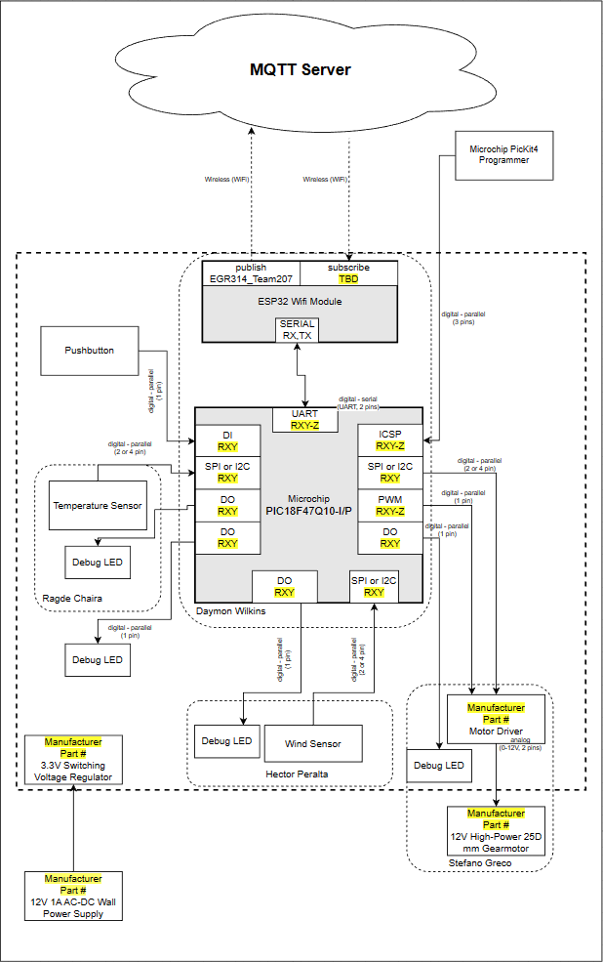

**Verification Table:**

